Java Persistence API

A Project Report Submitted

for

Information Technology
By

Diksha Tiwari

Under the guidance of
Mr. Praveen Kumar Joshi



EVER GREEN SENIOR SECONDARY SCHOOL
(GOVERNED BY EDUCATIONAL WELFARE SOCIETY)
TULARAMPUR –
263139, DISTRICT-NAINITAL
UTTARAKHAND, INDIA

OCTOBER, 2021

CERTIFICATE

This is to certify that the project entitled “Java Persistence API” being submitted to Evergeen Senior Secondary School, Haldwani for the project work of INFORMATION TECHNOLOGY is a record of the work carried by MR. PRAVEEN KUMAR JOSHI under my guidance and supervision.

Date: 10-10-2021 Supervisor
MR. PRAVEENJOSHI
TGT Computer
Ever Green Sr. Sec. School, Haldwani
Forwarded By:
MR. M.S. PARWAL
Principal
Ever Green Sr. Sec. School, Haldwani

ABSTRACT
This project is about the Java Persistence API (JPA) that is a specification of Java. It is used to persist data between Java object and relational database. JPA acts as a bridge between object-oriented domain models and relational database systems. It provides a platform to work directly with objects instead of using SQL statements. Java persistence API was first released as a subset of the EJB 3.0 specification in Java EE5. JPA has many compatible tools and frameworks; Hibernate is one of them. Hibernate is a Java framework that simplifies the development of Java application to interact with the database. It is an open source, lightweight, ORM (Object Relational Mapping) tool. Hibernate implements the specifications of JPA (Java Persistence API) for data persistence. Object- relational mapping is a task one that developers have good reason to avoid doing manually. Object -relational mapping is the functionality which is used to develop and maintain a relationship between an object and relational database by mapping and object state to database column. It is capable to handle various database operation easily such as inserting, updating, deleting etc . The Java persistence has entity that is an application defined-object in Java persistence library. An entity is a group of states associated together in a single unit. Each entity is associated with some metadata that represent the information of it. An object reference by an entity is managed by entity manager. Entity manager is used to read, delete and write an entity.

ACKNOWLEDGEMENTS
I would like to express my thanks of gratitude to my principal of my school “Mr. M.S. Parwal” who have given such a golden opportunity of doing this project work from which children learn something new and creative.
I would like to thank my IT teacher “Mr. Praveen Kumar Joshi” who had given such an interesting topic for the project and help the lot in completing this project.
Finally, I express my deepest gratitude to my parents for their continuous encouragement, understanding and support.

(Diksha Tiwari)

TABLE OF CONTENTS

Chapter | Topic | Page No.
 | CERTIFICATE | 2
 | ACKNOWLEDGEMENT | 4
 | LIST OF FIGURES | 7
 | ABSTRACT | 3
1. | INTRODUCTION | 7-8
1.1 | Java Persistence API | 7-8
1.2 | Application programming interface (API) | 8-9
1.2.1 | Purpose of API | 9-10
1.2.2 | Usage of API | 9-10
2. | JPA and Hibernate | 10-11
2.1 | Difference Between JPA and Hibernate | 10-11
3. | Java ORM (OBJECT-RELATIONAL MAPPING) | 10-11
3.1 | Mapping directions | 10-11
3.2 | Types of mapping | 11-12
4 | JPA entity introduction | 12-13
4.1 | Entity properties | 13-14
4.2 | Entity metadata | 13-14
4.3 | Entity operations | 13-14
5 | SUMMARY AND FUTURE WORK | 14-15
 | REFERENCES | 17-18

LIST OF FIGURES

S.No. | Name | Page No.
1. | Java Persistence API | 6-7
2. | API (Application Programming Interface) | 8-9
3. | JPA ORM (OBJECT-RELATIONAL MAPPING) | 10-11
4. | JPA Entity | 13-14

- Introduction

  - Java Persistence API

Data Persistence is a means for an application to persist and retrieve information from a non-volatile storage system. Persistence is vital to enterprise applications because of the required access to relational databases. Applications that are developed for this environment must manage persistence themselves or use third-party solutions to handle database updates and retrievals with persistence. The Java Persistence API (JPA) provides a mechanism for managing persistence and object-relational mapping and functions.
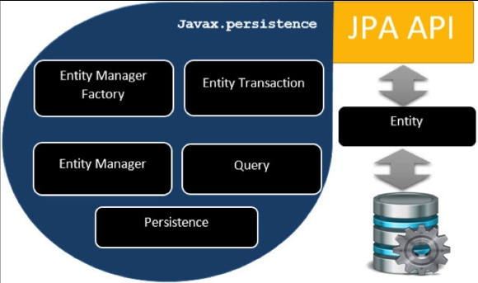

Figure 1:Java Pesistence API

  - Application Programming interface (API)

An application programming interface (API) is a connection between computers or between computer programs. It is a type of software interface, offering a service to other pieces of software. A document or standard that describes how to build such a connection or interface is called an API specification. A computer system that meets this standard is said to implement or expose an API. The term API may refer either to the specification or to the implementation. An API is often made up of different parts which act as tools or services that are available to the programmer. A program or a programmer that uses one of these parts is said to call that portion of the API. The calls that make up the API are also known as subroutines, methods, requests, or endpoints. An API specification defines these calls, meaning that it explains how to use or implement them. The term API is often used to refer to Web APIs, which allow communication between computers that are joined by the internet. There are also APIs for programming language, software libraries, computer operating systems, and computer hardware. APIs originated in the 1940s, though the term did not emerge until the 1960s and 70s.
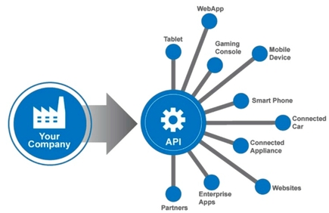
Figure 2:API (Application Programming Interface

    - Purpose of API
An API delivers a user response to a system and sends the system’s response back to a user. When we click “add to cart;” an API tells the site we added a product to our cart; the website puts the product in our cart, and our cart is updated. There are four basic request methods that can be made with API:
- GET – Gathers information (Pulling all Coupon Codes)
- PUT – Updates pieces of data (Updating Product pricing)
- POST – Creates (Creating a new Product Category)
- DELETE – (Deleting a blog post)

    - Usage of API
- A single API can have multiple implementations (or none, being abstract) in the form of different libraries that share the same programming interface.
- The separation of the API from its implementation can allow programs written in one language to use a library written in another. For example, because Scala and Java compile to compatible bytecode, Scala developers can take advantage of any Java API.

- JPA and Hibernate

Object-Relational Mapping (ORM) is the process of converting Java objects to database tables. The Java Persistence API (JPA) is a specification that defines how to persist data in Java applications. The primary focus of JPA is the ORM layer. Hibernate is one of the most popular Java ORM frameworks in use today. Its first release was almost twenty years ago, and still has excellent community support and regular releases. Additionally, Hibernate is a standard implementation of the JPA specification, with a few additional features that are specific in Hibernate. Hibernate is an open-source, lightweight, ORM (Object Relational Mapping) tool. The Hibernate is developed by Gavin king and released in early 2002.

  - Difference between JPA and Hibernate
JPA | Hibernate
- It defines the management of relational data in the Java applications. | - It is used to save the state of Java object into the database.
- It is defined in javax.persistencepackage. | - It is defined in org.hibernatepackage.
- It uses Java Persistence Language (JPQL) as an object-oriented query language. | - It uses Hibernate Query Language(HQL) as an object-oriented query language.

- Java ORM (Object-relational Mapping)
Object relational mapping (ORM) is a functionality which is used to develop and maintain a relationship between an object and relational database by mapping and object state to database column. It is capable to handle various database operations easily such as inserting updating deleting etc.

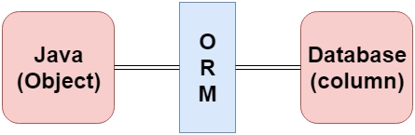
Figure 3: Java ORM (Object-relational mapping)
Following are the various frameworks that on ORM mechanism :-
- Hibernate
- TopLink
- ORMLite
- iBATIS
- JPOX

3.1. Mapping Directions
- Unidirectional relationship -A unidirectional relationship is valid in only one direction. The following are examples of unidirectional relationships: installed on, installed with, contains, member of, starts from, resides on, succeeded by, and preceded by.
- Bidirectional relationship - A bidirectional relationship is valid in both directions. Intersects is an example of a bidirectional
relationship.

3.2. Types of Mapping

Following are the various ORM mapping :-
- One-to-one
- One-to-many
- Many-to-one
- Many-to-Many

- JPA Entity Introduction

Entities in JPA are nothing but POJOs representing data that can be persisted to the database. An entity represents a table stored in a database. Every instance of an entity represents a row in the table. An entity is an application- defined object in Java Persistence library. Entities in JPA are nothing but POJOs representing data that can be persisted to the database. An entity represents a table stored in a database. Every instance of an entity represents a row in the table.
4.1. Entity Properties

These are the properties of an entity that an object must have: -

- Persistability - An object is called persistent if it is stored in the database and can be accessed anytime.
- Persistent Identity - In Java, each entity is unique and represents as an object identity. Similarly, when the object identity is stored in a database then it is represented as persistence identity. This object identity is equivalent to primary key in database.
- Transactionality - Entity can perform various operations such as create, delete, update. Each operation makes some changes in the database. It ensures that whatever changes made in the database either be succeed or failed atomically.
- Granuality - Entities should not be primitives, primitive wrappers or built-in objects with single dimensional state.

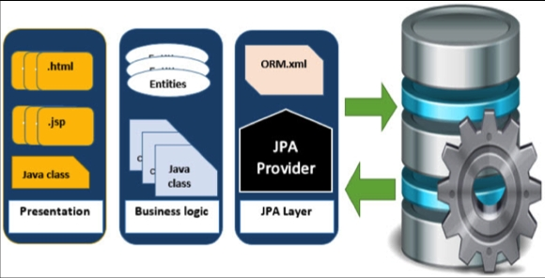
Figure 4:JPA Entity

  - Entity Metadata
Each entity is associated with some metadata that represent the information of it. Entity metadata is what controls the kinds of records you can create and what kind of actions can be performed on them. Metadata means data about data. Entity metadata is what controls the kinds of records we can create and what kind of actions can be performed on them.
  - Entity Operations
- Inserting an Entity
- Finding an Entity
- Updating an Entity
- Deleting an Entity

6. Summary and Future Work
In this tutorial, we have seen a high-level overview of Java persistence API. The JPA specification let us define which objects should be persisted, and how those objects should be persisted in your Java applications. Technically JPA is just set of interfaces (Specification) and thus require an implementation. Hibernate is a Java framework that simplifies the development of Java application to interact with the database. It is an open source, lightweight, ORM (Object Relational Mapping) tool. Hibernate implements the specifications of JPA (Java Persistence API) for data persistence. It needs ORM(Object Relational Mapping) implementation to work with and persist Java Objects. An ORM tool simplifies the data creation, data manipulation and data access. It is a programming technique that maps the object to the data stored in the database. The API defined in javax.persistence package. The JPA implementation is typically called persistence provider.
The mapping between Java objects and database tables is defined via persistence metadata. The JPA provider will use the persistence metadata information to perform the correct database operations. A class which should be persisted in a database it must be annotated with javax.persistence.Entity​. Such a class is called Entity. The JPA thereby helps us to minimize the effort required for the development and maintenance of database access modules in our application. JPA is not a tool of framework rather define a set of concept that can be implemented by any tool or framework. While JPA object-relational mapping model was originally based on Hibernate. A popular framework that support JPA with is Eclipselink.

Future work

In future if we want to switch our application form one ORM to another we can do it easily by using JPA.

References

- Jing, L., Ming, L., Bin, Y., Wenlong, L., A Novel Energy Efficient MAC Protocol for Wireless Body Area Network. China communication, Feb. 2015.
- Negra, R., Jemili, I., Belghith, A.: Wireless Body Area Networks: Applications and Technologies. Procedia Computer Science 83, 1274 – 1281 ( 2016 )
- Yuce, M.R.: Implementation of wireless body area networks for healthcare systems. In: Sensors and Actuators A: Physical, Vol 162, Issue 1, Pages 116-129. Elsevier B.V (2010)
- Dabhi, K., Mahet, A.: Internet of Nano Things-The Next Big Thing. In: International Journal of Engineering Science and Computing, vol 7 Issue No.4 (2017)
- Negra, R., Jemili, I., Belghith, A.: Wireless Body Area Networks: Applications and Technologies. Procedia Computer Science 83, 1274 – 1281 ( 2016 )
- Yuan, X., Li, C., Ye, Q., Zhan, K., Cheng, N., Zhan, N., Shen, X.: Performance Analysis of IEEE 802.15.6-Based Coexisting Mobile WBANs with Prioritized Trafﬁc and Dynamic Interference. In: IEEE Transactions on Wireless Communications (Volume: 17, Issue: 8, Aug. 2018)
- Adhikary S., Chattopadhyay S., Choudhury S.: A Novel Bio-inspired Algorithm for Increasing Throughput in Wireless Body Area Network (WBAN) by Mitigating Inter-WBAN Interference. In: Chaki R., Cortesi A., Saeed K., Chaki N. (eds) Advanced Computing and Systems for Security. Advances in Intelligent Systems and Computing, vol 667. Springer, Singapore (2018)
- Peng, H., Tian, Y., Kurths, J., Li, L., Yang, Y., Wang, D.: Secure and energy-efﬁcient data transmission system based on chaotic compressive sensing in body-to-body networks. IEEE Trans. Biomed. Circ. Syst. 11(3), 558–573 (2017)
- Samanta, A., Misra, S.: Energy-efﬁcient and distributed network management cost minimization in opportunistic wireless body area networks. IEEE Trans. Mobile Comput. 17, 376–389 (2017)
- Ahmad, S.S., Razzaque, M.A., Inmaculada T.R., Hussain, N.: IEEE 802.15.6 Standard in Wireless Body Area Networks From a Healthcare Point of View. The 22nd Asia-Pacific Conference on Communications (APCC2016)
- Yi, C., Wang, L., Li, Y.: Energy efﬁcient transmission approach for WBAN based on threshold distance. IEEE Sensors J. 15(9), 5133–5141 (2015)
- Misra, S., Moulik, S., Chao, H.-C.: A cooperative bargaining solution for priority-based data-rate tuning in a wireless body area network. IEEE Trans. Wirel. Commun. 14(5), 2769–2777 (2015)
- Walsh, M.J., Hayes, M.J.: Throughput rate control for an 802.15.4 wireless body area network using static and low order anti-windup techniques. In: Proc. Mediterranean Conf. Control Autom, pp.1–6 (2007)
- Eberhart, R., Kennedy, J.: A New Optimizer Using Particle Swarm Theory. Sixth International Symposium on Micro Machine and Human Science, 0-7803-2676-8/95
- Kalaiselvi, K., Suresh, G.R. & Ravi, V.: Genetic algorithm based sensor node classiﬁcations in wireless body area networks (WBAN). Cluster Comput (2018)
- Nadeem, Q., Javaid, N., Mohammad, S.N., Khan, M.Y., Gull, M.: SIMPLE: Stable Increased-throughput Multi-hop Protocol for Link Efﬁciency in Wireless Body Area Networks. 26, Jul. 2013.

